Mykle Efren Garcia

2ECE-B

Programming Assignment:

Problem 1: Screenshot 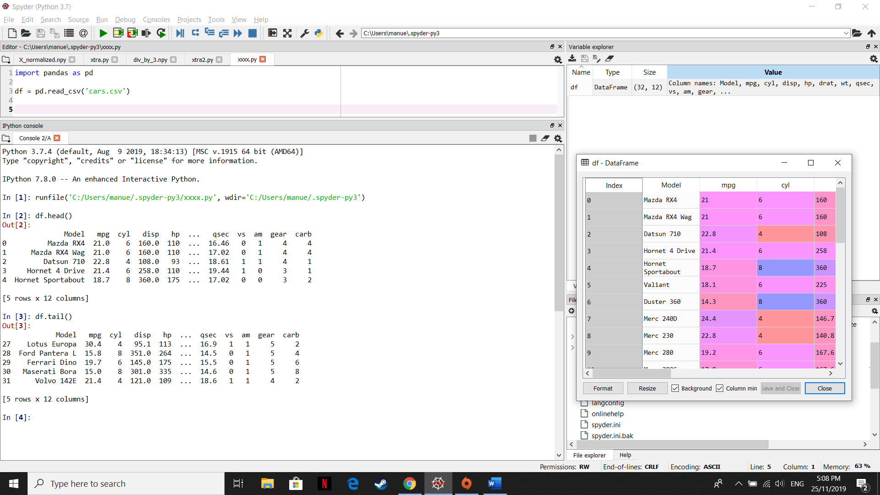

Problem 2: Screenshot

